**Pb detection by multisensory system**

Predicted vs measured plot after removing point '0'. The 3-component model selected due to reasonable value of X and Y cumvariance.

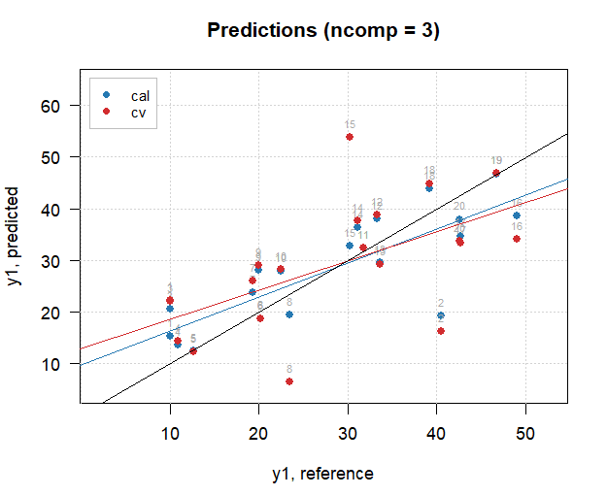

Predicted vs measured plot after removing points '0', '2', '16', '1' and cleaning X-variables (TPDO, T100K10, PbGl and CdGl was left). 3 components were chosen. It is also possible to remove point 3.

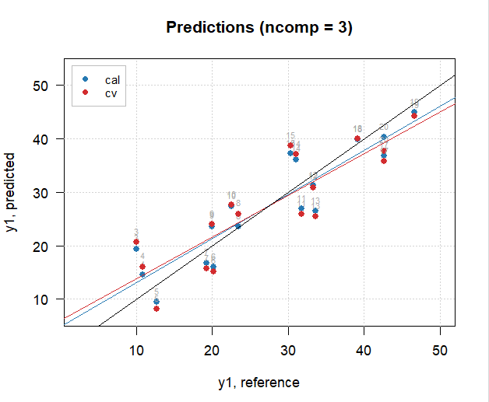

**Pb detection by the electrochemical sensor**

The X-variable represent average sensors responses from 3 repetitions. The repetitions were preliminary selected based on PCA results.

Predicted vs measured plot before removing point outliers (there are no point ‘0’ in the dataset).

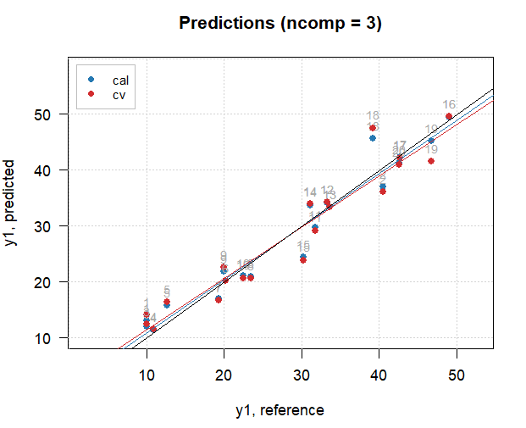

Predicted vs measured plot after removing points '18', '15'.

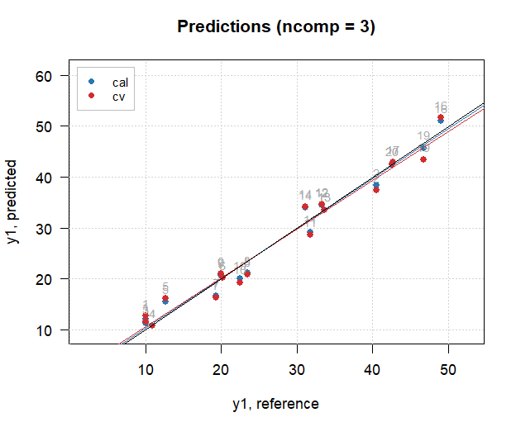

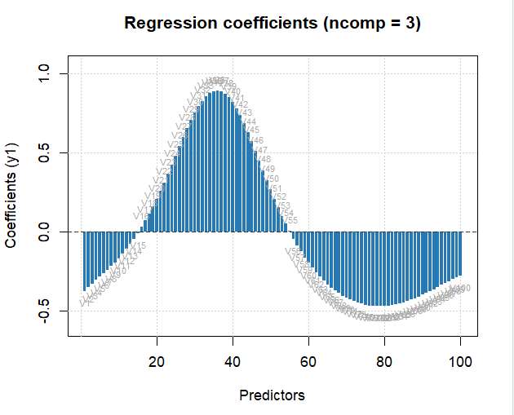

**Pb detection by data fusion**

Before removing the outliers (no point 0):

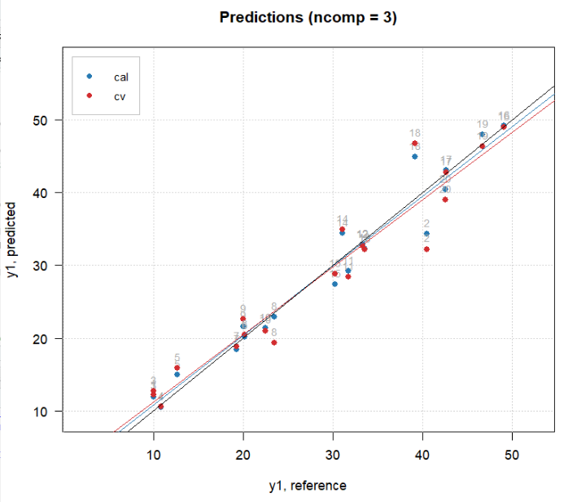

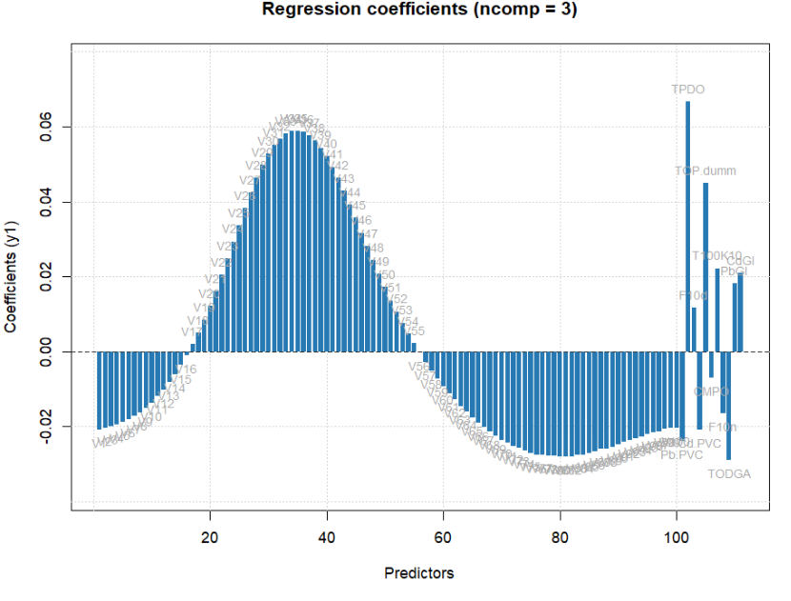

After removing points 2 and 18:

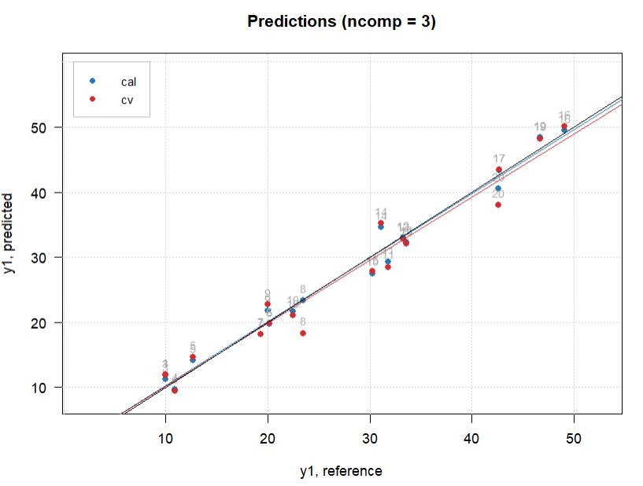

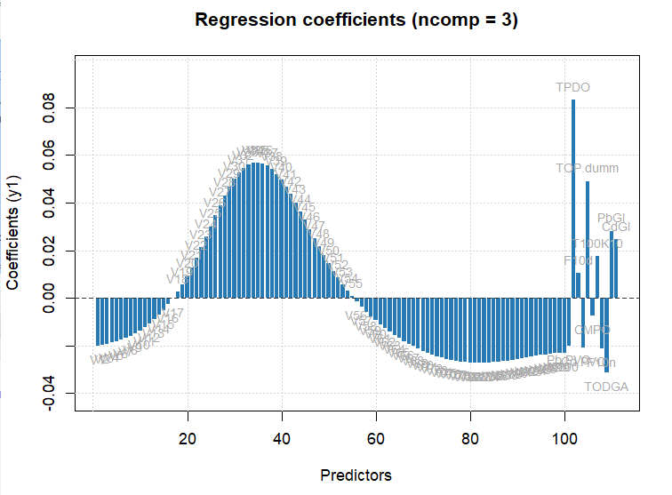

**Cd detection by multisensory system**

Before removing any points except for 0:

1. 1-component model

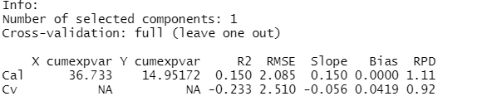

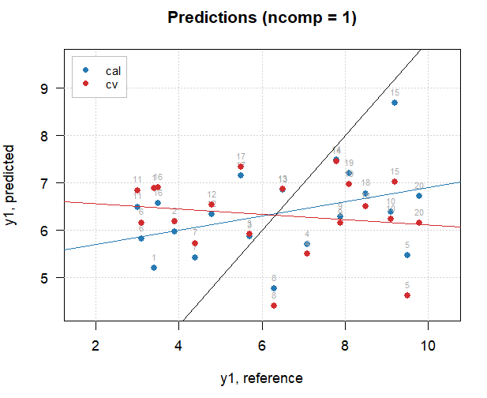

1. 4-component model

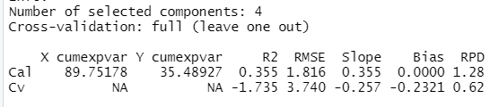

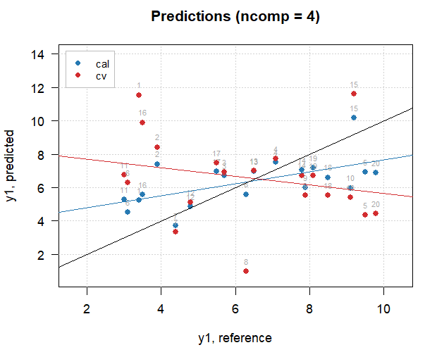

Predicted vs measured plot after removing points '0', '1', '16', '5'. 3 components were chosen to provide better X-CumVariance. Despite the removing of possible outliers, the RMSECV and Y-CumVariance are still poor. Besides, regression coefficients seem overfitted.

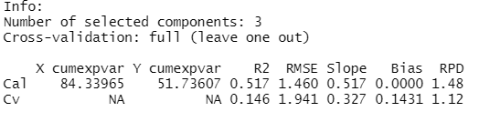

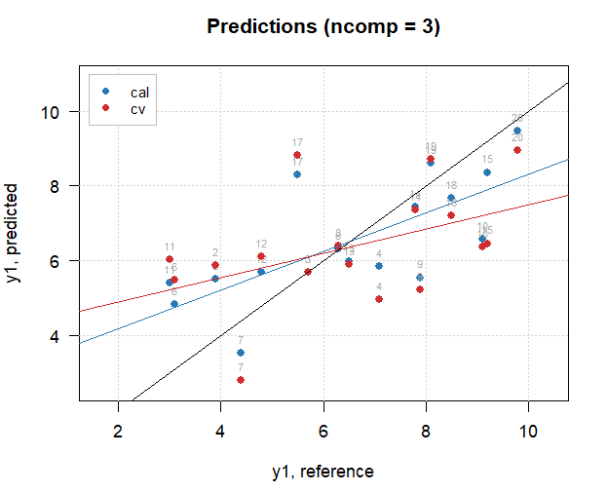

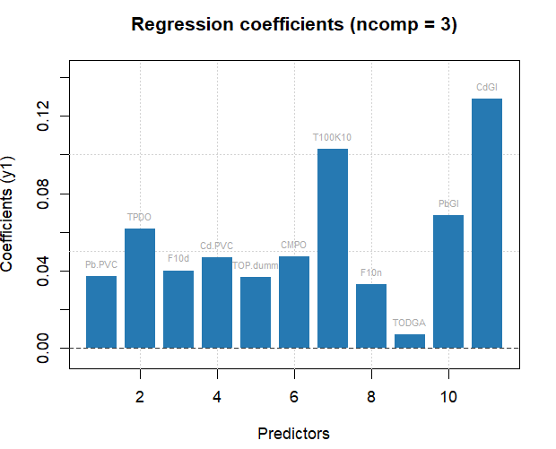

**Pb detection by the electrochemical sensor**

PCA showed that the 1st replica has the best correlation between variables, therefore it was chosen for the analysis.

Results for the data with all points except for “0”. Only 1-component model represents the normal behavior of the regression coefficients (although it gives poor Y-CumVariance).

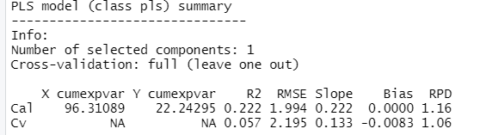

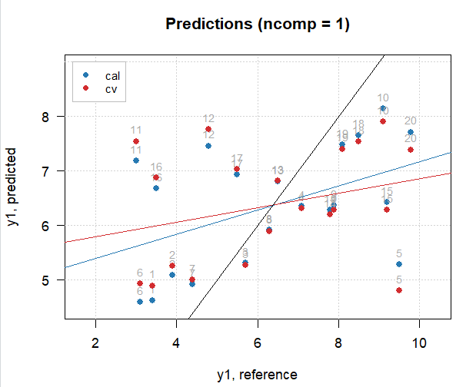

Predicted vs measured plot after removing points '0','11', '5', '12', '16'.

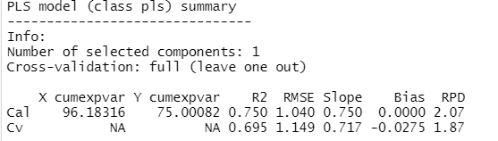

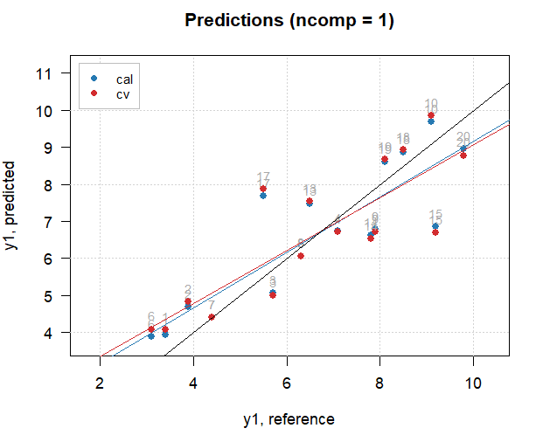

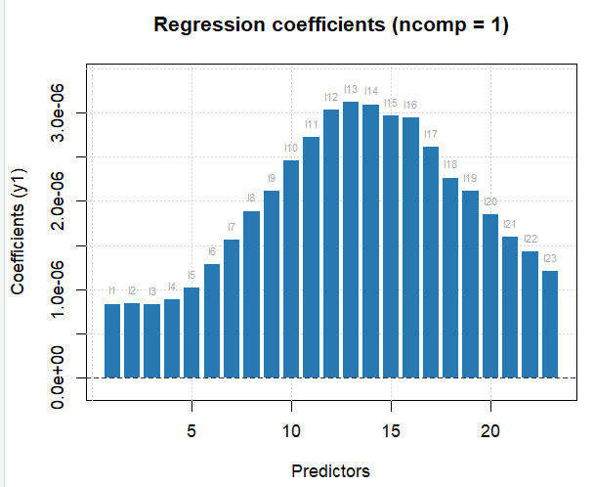

**Cd detection by data fusion**

Before removing any points except for 0:

(1-component so that minimum RMSECV)

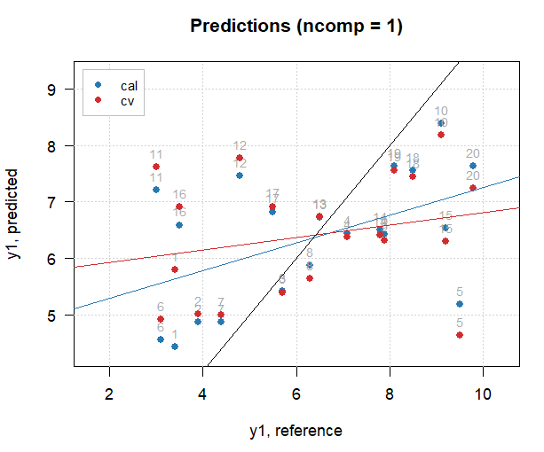

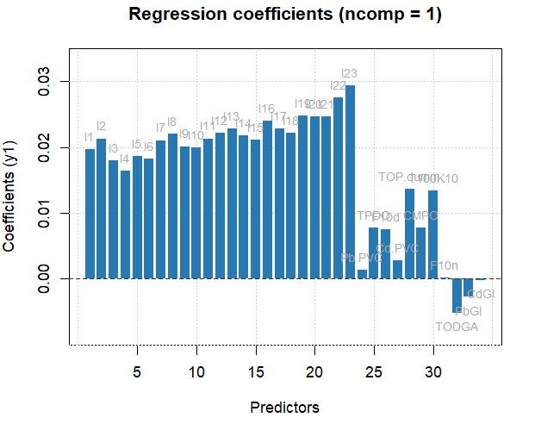

Predicted vs measured plot after removing points '0', '11', '5', '12', '16'. Applying more than 1 component increases the RMSECV/C.

